Shopping-Cart APP

**Wireframe Documentation**

HOME PAGE

Homepage will have Store page, that will access you to get all the products that the user wanted to have into their cart with quantity.

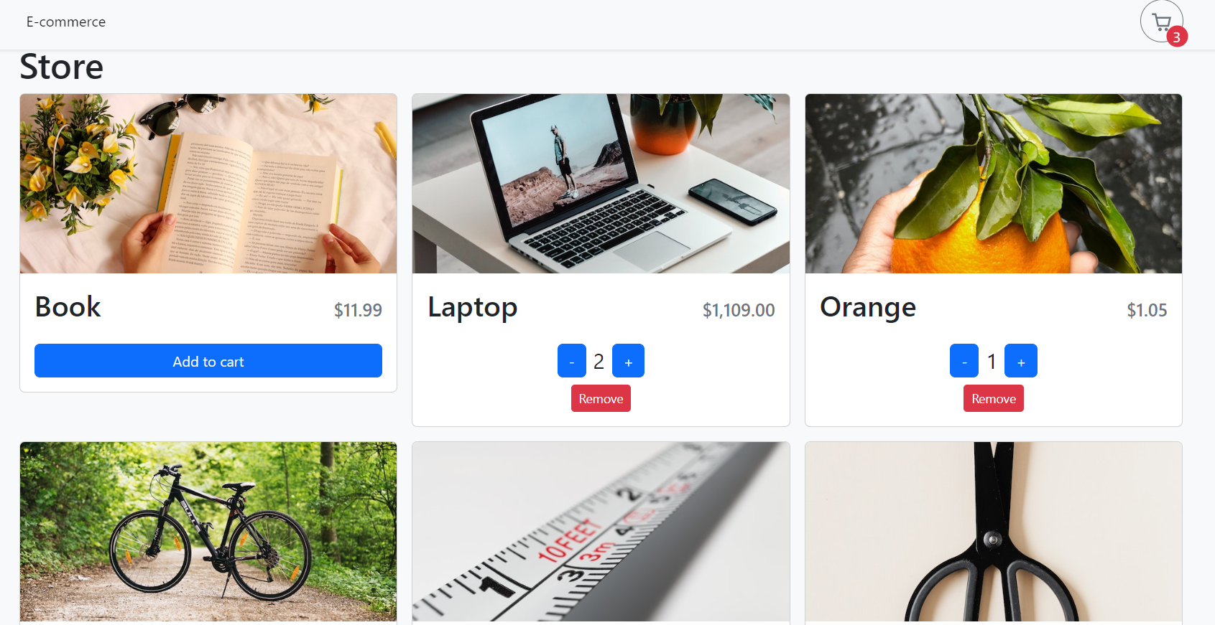

Cart

After addition of Products into their cart user can see their products with the total amount

